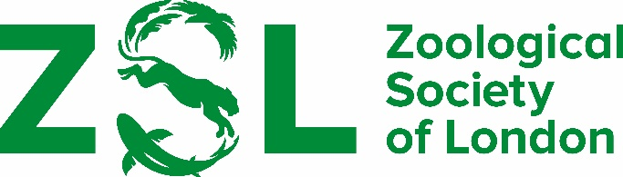

The Charles Darwin Award and Marsh Prize
2023

awarded by
THE ZOOLOGICAL SOCIETY OF LONDON

The winner of the ZSL Charles Darwin Award and Marsh Prize receives a certificate and a monetary prize of £1000.

The Award is open to undergraduate students attending university in Great Britain or Northern Ireland for an outstanding zoological project carried out during the academic year September 2022 to August 2023. Projects completed a month before or a month after these dates will be considered. Entries can only be considered once for the award.

Heads of Department are requested to recommend one undergraduate research student whose project was considered to be outstanding.

A letter or recommendation, along with the project and a detailed report on the candidate’s work, should be sent to:

The Secretary of the Awards Committee, c/o Linda DaVolls
The Zoological Society of London, Regent’s Park, London, NW1 4RY.

Submissions can be emailed to linda.davolls@zsl.org

Recommendations must be received by 15 April 2024

The following additional information should also be submitted:

- The degree the candidate is studying
- The length of time over which the project was undertaken
- The nature and extent of assistance given to the undergraduate

The Council of ZSL request that the candidate should not be told of the recommendation.

