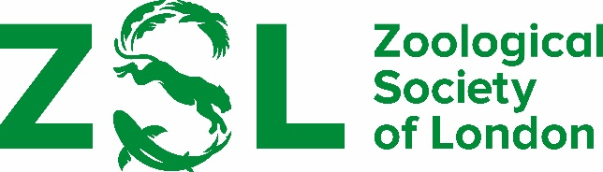

RECOMMENDATION OF CANDIDATES FOR THE ZSL
CLARIVATE AWARD FOR COMMUNICATING ZOOLOGY

Regulations

- No serving member of Council or the Scientific Awards Committee is eligible to be nominated for the award.

- The award will be given to an individual for a communication of a zoological nature that has an outstanding impact on a general audience. The means of communication may include a film, a series of films, a book, or an article on any zoological topic. The impact may be measured in terms of outstanding quality, novelty, innovation or accessibility for a wide audience.

- The material to be considered must have been released or published within the 12 months prior to the submission deadline.

- No more than one award may be made annually.

- The same individual may receive the award in different years for different pieces of work.

- The award will include a cheque for £1000 payable to the winner.

Recommendations must be received by 15 April 2024.

Please email your recommendations to linda.davolls@zsl.org

