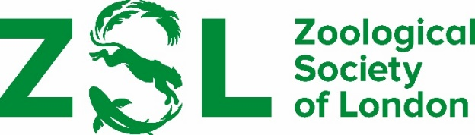

RECOMMENDATION OF CANDIDATES FOR THE ZOOLOGICAL SOCIETY OF LONDON FRINK MEDAL FOR BRITISH ZOOLOGISTS

Regulations

- No serving member of Council is eligible to be nominated for the award.

- The award may be made annually to a professional zoologist for substantial and original contributions to the advancement of the science.

- Candidates must be British citizens or residents in the United Kingdom and whose work is based here.

- The award will be a bronze medal by Dame Elisabeth Frink.

Nominations should be made using the form below and emailed to linda.davolls@zsl.org

Recommendations must be received by 15 April 2024

NOMINATION FORM

ZSL Frink Award

Name of candidate:

Address:

Statement in support of recommendation

Curriculum vitae if possible, please enclose candidate’s CV

Publications if possible, please enclose a list of candidate’s publications

Proposed by

Signed

