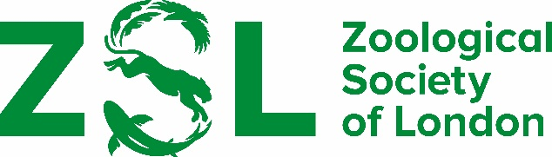

RECOMMENDATION OF CANDIDATES FOR THE ZSL/MARSH AWARD FOR CONSERVATION BIOLOGY

Regulations

- The award will be given for contributions of fundamental science with application to the conservation of animal species and habitats.

- Serving members of Council or the Scientific Awards Committee are not eligible to be nominated for the award.

- Preference will initially be given to candidates who are citizens of the United Kingdom or who have spent a significant part of their scientific career in the UK.

- Nominations will be sought and considered annually but, if in any year no candidate is thought to merit the award, it will not be made.

- Nominations must be supported by a statement of recommendation and accompanied by the names and addresses of at least two referees, of whom at least one should be resident in the United Kingdom.

- Candidates nominated but not selected in any year may, at the discretion of the Scientific Awards Committee, be reconsidered in subsequent years.

- The award may not be given for a piece of work already recognised by the Marsh Award for Marine and Freshwater Conservation

Nominations should be emailed to linda.davolls@zsl.org by 15 April 2024

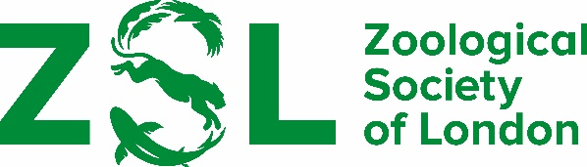

Recommendation of candidates for the

ZSL/Marsh Award for Conservation Biology

Name of candidate

Address

Statement in support of recommendation

Curriculum vitae if possible, please enclose candidate’s CV

Publications If possible, please enclose a list of candidate’s publications

Referees Please give names and address of two people (at least one of whom should be resident in the United Kingdom) who are familiar with the candidate’s work and might be approached for further comment

Proposed by

Signed Date

