The 2023 Prince Philip Award & Marsh Prize for studies in animal biology

The Prince Philip Award and Marsh Prize is open to students under 19 years old in the competition year. Entrants must be/have been pupils of a school/college in Great Britain or Northern Ireland. The winner receives a monetary prize (£600) and a certificate.

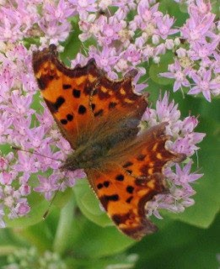
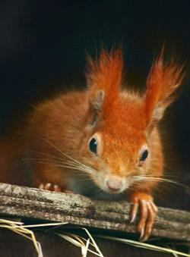
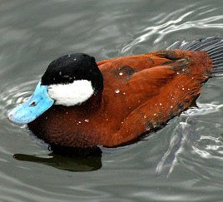
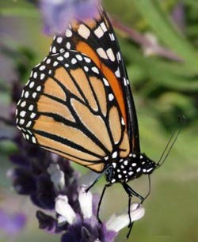
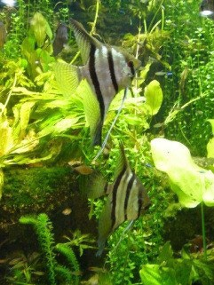
Project Guidelines
The entry should be a written account of practical work involving some aspect of animal biology, e.g. behaviour, physiology or ecology. Students should identify one or two simple problems to solve or study areas to concentrate on, rather than try to discover everything about the animals being investigated.

The project should be about 3000 words and include photos, tables and graphs. The introduction should explain the aims of the study and show relevant background reading. Experimental results should be replicated where possible and appropriate controls used. The interpretation of results and discussion should describe the findings and highlight potential areas for future research.

The project should be of a standard comparable with an A‐Level project or Higher.

Features of a good project include:
- testable hypotheses
- sound methodology to collect data relevant to the hypotheses
- appropriate statistical analysis and critical interpretation

Presentation
The study should be presented in the style in which scientific work is published. Genus and species names should be italicized; graphs should be labelled and the units given.
Published material should be acknowledged and references given. Long tables of results and their statistical treatment should be included in the appendices. The nature and the extent of any help received should be specified in the cover letter.

The final project should include the following sections

- Title page, giving the name of the project, the author(s), the name, address and contact details of the school or college

- Abstract (an abbreviated version of the project)

- Table of contents

- Introduction. The introduction should introduce the reader to the aims and context of the study. It should state why the project was undertaken and give a brief account of any background reading.

- Hypothesis. A testable hypothesis should be presented. The nature of the problem to be investigated should be clearly defined using relevant biological knowledge, principles and concepts. Limitations of the study, such as small sample sizes or limited control over experimental manipulations, should be given.

- Materials and Methods. Describe the experimental procedure in sufficient detail in order for the study to be replicated. Use appropriate controls as required. The choice of apparatus and materials should be described and justified. The number and types of observations and measurements should be explained. Where appropriate, a risk assessment of hazardous procedures or substances should be undertaken. Consideration should be given to the ethical implications of the research, as appropriate.

- Data Analysis and Results. Ensure there is sufficient data to test whether your hypothesis is correct. Ensure that units of measurement are given for all data.

- Results and Discussion. The interpretation and discussion of results should include consideration of the limitations of the work undertaken. The results should be restricted to a factual account of the findings. The Discussion should point out the significance of the results in relation to the reasons for undertaking the research.

- Conclusions. Summarize your results and use these to support your findings. State whether you proved or disproved your hypothesis. Summarize and evaluate the experimental procedure and comment on its success and effectiveness. Suggest how the experimental procedure could be improved.

- Ideas for Future Research. You should indicate what additional research might be carried out based on what you have learned.

- Acknowledgements

- Reference list. The bibliography should list all books, journals and Internet sources used to research the topic. To cite a source, put the author's name and the date of the publication in parentheses (Author, date) in your text. The source must be listed in a reference list.

The reference for each source should include:

- Author name
- Title of the publication (and title of the article if it appears in a journal or encyclopedia)
- Date of publication
- Place of publication and publisher (for a book)
- The volume number of a journal or encyclopedia
- Page numbers

Examples of References

References must be arranged first alphabetically under author(s) name(s) and then in chronological order if several papers by the same author(s) are cited.

Jones, P. (2006). Relationships between hand morphology and feeding in prosimians. Journal of Zoology 273: 148‐156.

White, A. (2002). Hystricomorph vocalisations. In The biology of hystricomorph rodents: 101‐125. Rowntree, A. (Ed.). London: Chapman & Hall.

Terms
Entrants must be under 19 years old in the competition year and must be/have been pupils of a school/college in Great Britain or Northern Ireland.

Head teachers and/or senior science staff are asked to select entries of an appropriate standard. An entry may be the work of one individual or a joint project from not more than two pupils.

Each entry must be accompanied by a letter from the teacher giving the full name, address and date of birth of the pupil, and the name and address of the school/college. The letter should indicate the nature and extent of any assistance given to the student(s).

Assessment
Entries will be assessed by a panel of scientists and education officers and marked on accuracy of observation, planning, interpretation, significance of conclusions, and neatness of presentation.

Entries should be sent to: Linda DaVolls, ZSL Awards Committee, Zoological Society of London, Regent’s Park, NW1 4RY, by 15 April 2024

For more information please contact: linda.davolls@zsl.org

Many thanks to the Marsh Charitable Trust for supporting this award.

Photos © Tony Weeks; http://www.copyright-free-pictures.org.uk/ ; Kathryn Hedges http://pics.tech4learning.com

