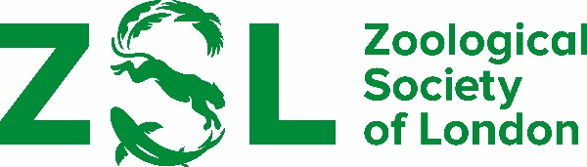

RECOMMENDATION OF CANDIDATES FOR THE SILVER MEDAL

Regulations

- No serving member of Council is eligible to be nominated for the award.

- The medal may be awarded to a Fellow of the Society or any other person or persons for a body of work that contributes to the public understanding and appreciation of zoology, including such activities as citizen science, education in natural history, and promoting participation in wildlife conservation.

- Recommendations are requested annually, but the award will only be made occasionally.

Recommendations must be received by 15 April 2024

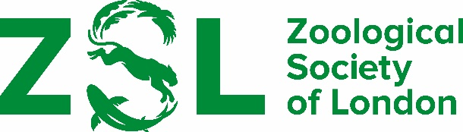

Recommendation of candidates for the Silver Medal

Awarded to a Fellow of the Society or any other person for contributions to the understanding and appreciation of zoology, including such activities as higher and public education in natural history, and wildlife conservation.

Name of candidate

Address

Statement in support of recommendation

Curriculum vitae if possible, please enclose candidate’s CV

Publications if possible, please enclose a list of candidate’s publications

Referees if possible, please give names and address of people familiar with the candidate’s work who might be approached for further comment

Proposed by

Signed Date

