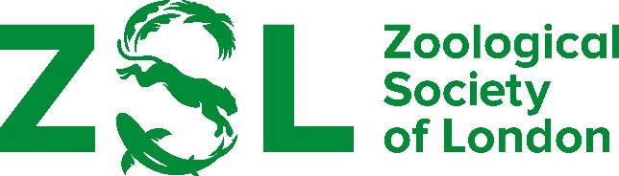

**RECOMMENDATION OF CANDIDATES FOR THE ZSL CLARIVATE AWARD FOR COMMUNICATING ZOOLOGY 2024**

# Regulations

1. No serving member of Council or the Scientific Awards Committee is eligible to be nominated for the award.
2. The award will be given to an individual for a communication of a zoological nature that has an outstanding impact on a general audience. The means of communication may include a film, a series of films or a book on any zoological topic. The impact may be measured in terms of outstanding quality, novelty, innovation or accessibility for a wide audience.
3. The material to be considered must have been released or published within the 12 months prior to the submission deadline.
4. No more than one award may be made annually.
5. The same individual may receive the award in different years for different pieces of work.
6. The award will include a cheque for £1000 payable to the winner.

# Recommendations must be received by 25 March 2025.

# Please email your recommendations to [linda.davolls@zsl.org](mailto:linda.davolls@zsl.org)