
The Thames European Eel Project Report 2025
Estuaries and Wetlands Conservation Programme
November 2025

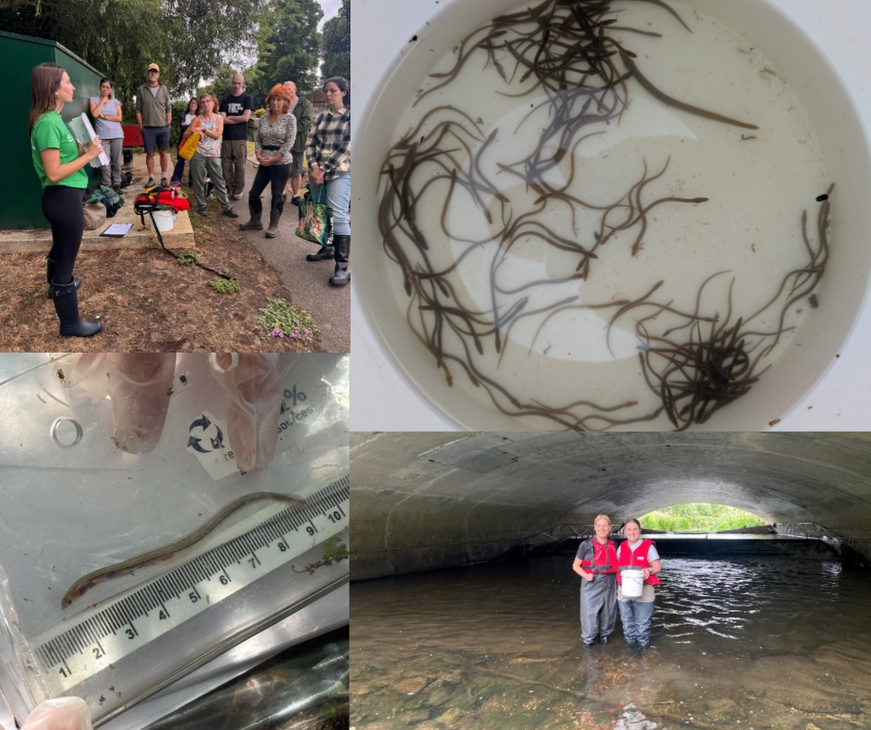

Acknowledgements

The conservation efforts conducted through the Thames European Eel Project in 2025 were made possible through the generous funding provided by the John Ellerman Foundation and the Marshall Wace Wildlife Conservation Project. We would like to thank the Environment Agency, along with our partners who supported monitoring this year, including SEA LIFE London Aquarium, Medway Valley Countryside Partnership and the South East Rivers Trust. We are also grateful to the many organisations that have contributed since the project launched in 2005. Above all, we owe a special thanks to the dedicated citizen science volunteers who have devoted their time to monitor the eel traps and make this project possible.


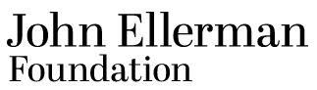

Contact: marineandfreshwater@zsl.org

Authors: Ella Carbery-Tarrant (ZSL), Azra Glover (ZSL), Joe Pecorelli (ZSL)

ISBN number: N/A
Table of Contents
Acknowledgements 2
1. Introduction 5
1.1 Background 5
1.2 European Eels In The Thames 6
1.3 The Zoological Society of London’s Thames European Eel Project 7
2. Methodology 9
2.1 Trap Locations 9
2.2 Trap Design 9
2.3 Citizen Science Training 10
2.4 Monitoring Method 11
2.5 Data Processing 12
3. Results 13
3.1 Eel Catches 13
3.2 Catch Per Unit Effort (CPUE) 14
4. Discussion 17
4.1 Catch Data 17
4.1.1 Medway - Allington Lock 17
4.1.2 Roding - Redbridge Roundabout 17
4.1.3 Thames - Molesey Weir 18
5. References 19

1. Introduction

1.1 Background
The European eel (Anguilla anguilla) has been listed as Critically Endangered on the International Union for the Conservation of Nature (IUCN) Red List of Threatened Species since its first evaluation in 2008 (Pike et al., 2020). Populations have declined by as much as 98% across all life stages of European eel since the 1980s, and despite ongoing conservation measures, the population continues to decrease (Pike et al., 2020, Sonne, 2021).
Eel recruitment - the number of young eels entering rivers each year - is a widely used metric utilised for monitoring eel populations. Recent International Council for the Exploration of the Sea (ICES) stock advice (2025) shows that eel recruitment across their range remains critically low and below safe biological limits (Harrison et al., 2014). As a result, ICES advises that there should be no recreational or commercial fishing of European eel, including the capture of glass eels for restocking and aquaculture. It further recommends that non-fisheries related anthropogenic mortalities should be reduced to zero, and that the quantity and quality of eel habitats should be restored (ICES, 2025). According to the 2025 ICES stock advice, indices for both glass and yellow eel recruitment show a sustained long-term decline from 1980 to 2011 (ICES, 2025). These recruitment indices are expressed as percentages of the 1960 to 1979 geometric mean. As shown in Figure 1.1, glass eel recruitment in the North Sea index area was 0.7% in 2025 (preliminary data) and 1.3% in 2024 (updated). In the Elsewhere in Europe index series, recruitment was 12.1% in 2025 (preliminary data) and 7.2% in 2024 (updated). The yellow eel recruitment index for 2024 was 14.3% (updated) of the 1960 to 1979 geometric mean.

To address these severe declines, the European Commission Regulation EC no. 1100/2007 ‘Establishing measures for the recovery of the stock of European eel’, was introduced in 2007. This legislation requires Member States with suitable habitat to develop Eel Management Plans (EMP) for their river basin districts (Council Regulation (EC) No 1100/2007, 2007). Since Brexit the regulation has been incorporated into UK domestic law.

Since the launch of the Thames Eel Management Plan, the Zoological Society of London (ZSL) has co-chaired the Thames EMP Implementation Group alongside the Environment Agency.

In 2025, The Thames Eel Management Plan was superseded by the Thames Eel Action Plan (TEAP). Guided by the vision set out in the Environment Agency (EA) Eel Charter to establish thriving eel populations across suitable habitats, the TEAP focuses on addressing local challenges while contributing to broader conservation efforts and recognising the range-wide threats to the species. The plan was co-developed by 23 regional stakeholders.

The TEAP can be found on the ZSL Website and is available here.

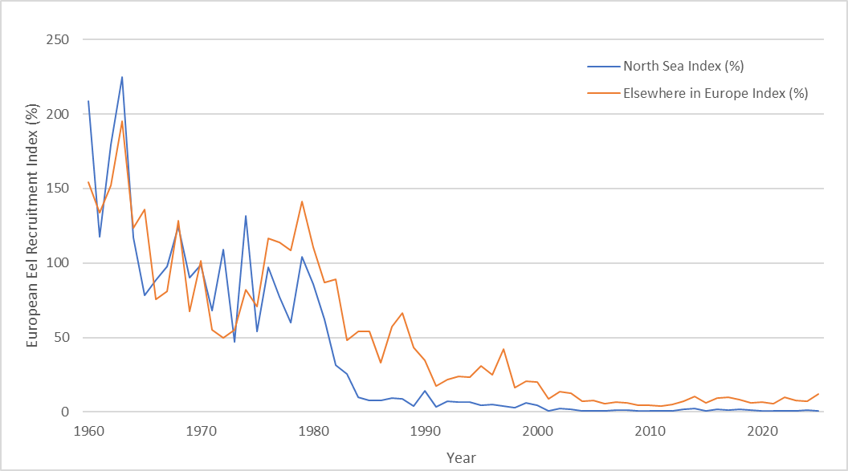
Figure 1.1: European eel (Anguilla anguilla) stock recruitment indices from 1960 to 2025 for the North Sea (blue line) and Elsewhere in Europe (orange line) indices. Index values represent eel recruitment as a percentage relative to the geometric mean of 1960 to 1979 values. 2025 values are preliminary. Data obtained from ICES stock advice (2025).

Declines in eel recruitment are attributed to a combination of anthropogenic factors, climatic conditions and changes in oceanic currents, affecting all stages of the European eel life cycle (Gollock et al., 2011, Righton et al., 2025). Direct anthropogenic factors affecting juvenile recruitment and adult escapement include habitat loss, pollution, barriers to dispersal (such as weirs, locks and sluices), hydropower impacts and overfishing (Feunteun, 2002). Illegal trafficking also continues to pose a serious threat on the species, with European eels among the most trafficked animals in Europe (Pons-Hernandez, 2024). Together, these stressors have driven the ongoing decline of eel recruitment across the UK and globally (Jacoby et al., 2015).

1.2 European Eels In The Thames
The European eel has one of the most complex life cycles of any freshwater fish (Figure 1.2). Larvae, known as leptocephali, hatch from eggs in the Sargasso Sea and drift on oceanic currents towards Europe. Upon reaching estuaries, leptocephali metamorphose into glass eels and begin their upriver migration. During this stage they undergo pigmentation and become elvers. Some elvers remain in estuarine waters, while others migrate inland up to 60km upriver. As they grow, their undersides develop a yellow pigment and transform into the yellow eel stage. Yellow eels remain in a defined stretch of river for 12-20 years depending on food availability, habitat suitability and temperature where they feed and sexually mature. Mature eels undergo another transformation into silver eels becoming the migratory adult form. Silver eels begin their catadromous journey downstream and across the Atlantic back to the Sargasso Sea to spawn. After spawning, they are believed to die, making them a semelparous species (Wright et al., 2022).

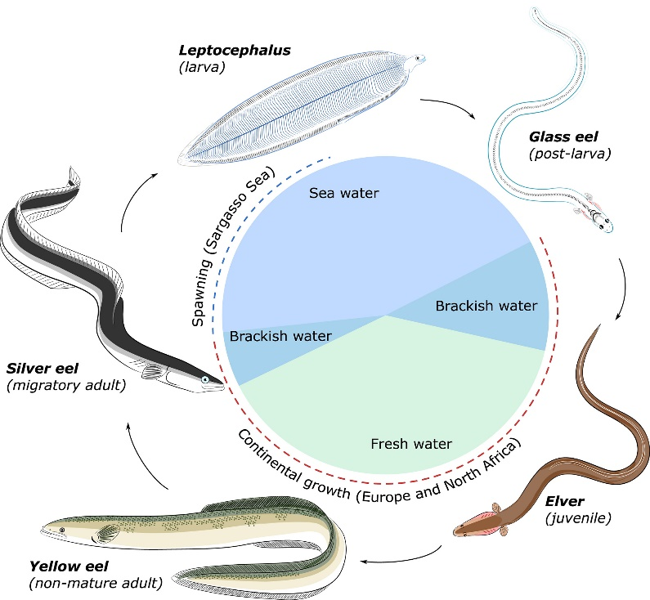

Figure 1.2: The life cycle of the European eel (Anguilla anguilla) (Cresci, 2020).

The Thames River Basin District (RBD) comprises 11% of the freshwater and lake habitat within England and Wales, historically providing important eel habitat (Department for Environment, Food and Rural Affairs (DEFRA), 2010, Naismith and Knights, 1988). Southeast England is now one of the most urbanised and heavily engineered regions in the UK, with weirs, dams and flood defences creating major barriers to eel migration (DEFRA, 2010). Recent studies have also identified that juvenile eels face severe migration bottlenecks in urban rivers due to hydrological alternations and structural barriers (Griffioen et al., 2024).

1.3 The Zoological Society of London’s Thames European Eel Project
The Thames European Eel Project (TEEP) was launched by ZSL in 2005 to monitor upstream elver migration within the Thames RBD and compare recruitment levels with those recorded in the 1980s. Monitoring initially took place at three sites on the rivers Darent, Roding and Mole using traps positioned at river barriers during the elver migration season (April to September). Since then, 23 sites have been monitored including three long-term index sites: Medway - Allington Lock, Roding - Redbridge Roundabout and Thames - Molesey Weir. These sites continue to provide valuable datasets since the citizen science element of the project was launched in 2011.

Over time, the project has expanded in scope and now focuses on three aims.

    - To deliver European eel conservation within the Thames RBD.
The primary aims of the TEEP are to improve connectivity within the Thames RBD and enable elvers to reach upstream habitats for feeding and growth. Since 2013, the project has contributed to the construction of 12 eel passes, opening an estimated 139 hectares of habitat. Furthermore, through partnerships and tools like ObstacEELS, a survey method that assesses the passability of structures for eels, the project can identify and prioritise barriers for remediation. The addition of monitoring newly installed eel passes also provides evidence to prioritise future conservation actions.

    - To contribute to regional and national management of European eels.
ZSL co-host the TEAP Working Group with the Environment Agency. The TEAP Working Group was set up to support a partnership-based approach to delivering regional action for eel. Annual meetings are held to update stakeholders with conservation priorities, share best practice and foster collaboration.

    - To support evidence-based policy and international management of European eel stock.
TEEP provides long-term recruitment data from its three index sites within the Thames RBD. Data is annually submitted to the joint European Inland Fisheries and Aquaculture Advisory Commission (EIFAAC), ICES and General Fisheries Commission for the Mediterranean (GFCM) Working Group on Eels (WGEEL) to supplement evidence to inform annual stock assessments.

2. Methodology

2.1 Trap Locations
In 2025, The TEEP’s three index sites were monitored using eel traps at the following locations (Figure 2.1):
- Medway - Allington Lock
- Roding - Redbridge Roundabout
- Thames - Molesey Weir

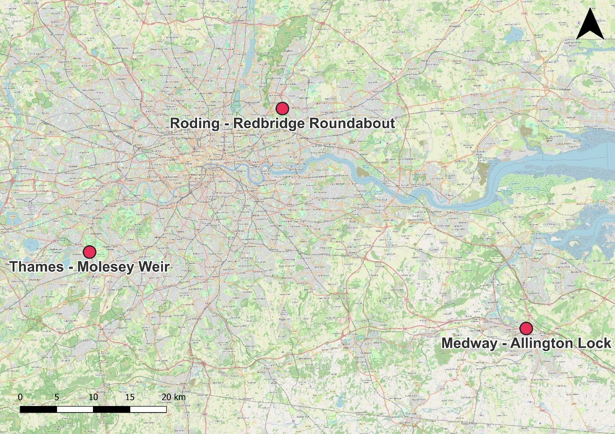
Figure 2.1: European eel (Anguilla anguilla) monitoring locations across the Thames River Basin District in 2025.

2.2 Trap Design
Traps are installed at river barriers, such as weirs and locks, where elvers naturally congregate while searching for an upriver passage passed such obstacles (Harrison et al., 2014). This makes them ideal monitoring points for assessing eel recruitment.

The standard trap design, developed by Naismith and Knights (1988), has been continually used at the two Roding - Redbridge Roundabout traps for 20 years. As shown in Figure 2.2, water is channelled down a guttering pipe, lined with a climbing substrate such as netting, positioned beside the weir. Elvers use this substrate to climb upward into a holding tank, where they remain safely sheltered from predators and direct sunlight until the trap is checked (Piper et al., 2012). The holding tank remains oxygenated by a constant flow of water, maintained by a mesh overflow and supply pipe which also feeds the guttering pipe. This simple, low maintenance design allows for consistent data collection over long time periods.

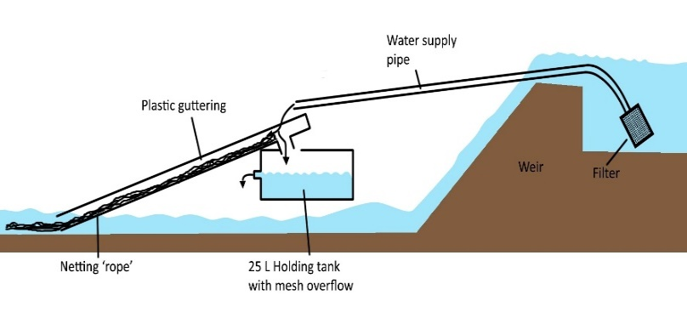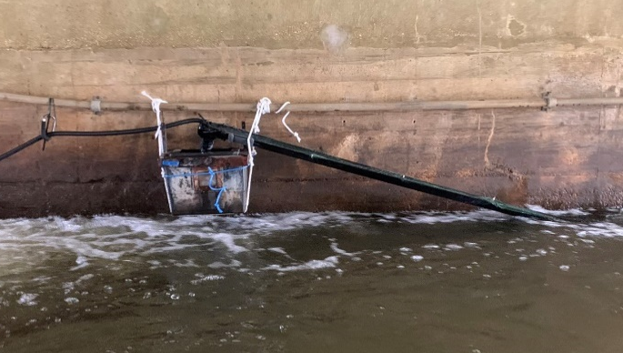
a) b)

Figure 2.2: a) Schematic and b) photograph of the basic trap design at the Roding - Redbridge Roundabout site. Schematic taken from Naismith and Knights (1988), image credit: ZSL\Ella Wallis.

At the Medway - Allington Lock and Thames - Molesey Weir, the trap design follows the same principle but is integrated directly into an already existing eel pass (Figure 2.3). As elvers move through the pass, they are intercepted part-way and diverted into a holding tank where they cannot progress further or return downstream. Water flow through this system is maintained by gravity, ensuring a steady, natural flow that supports eel passage and trap function.

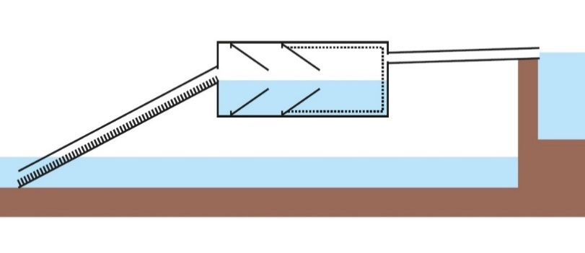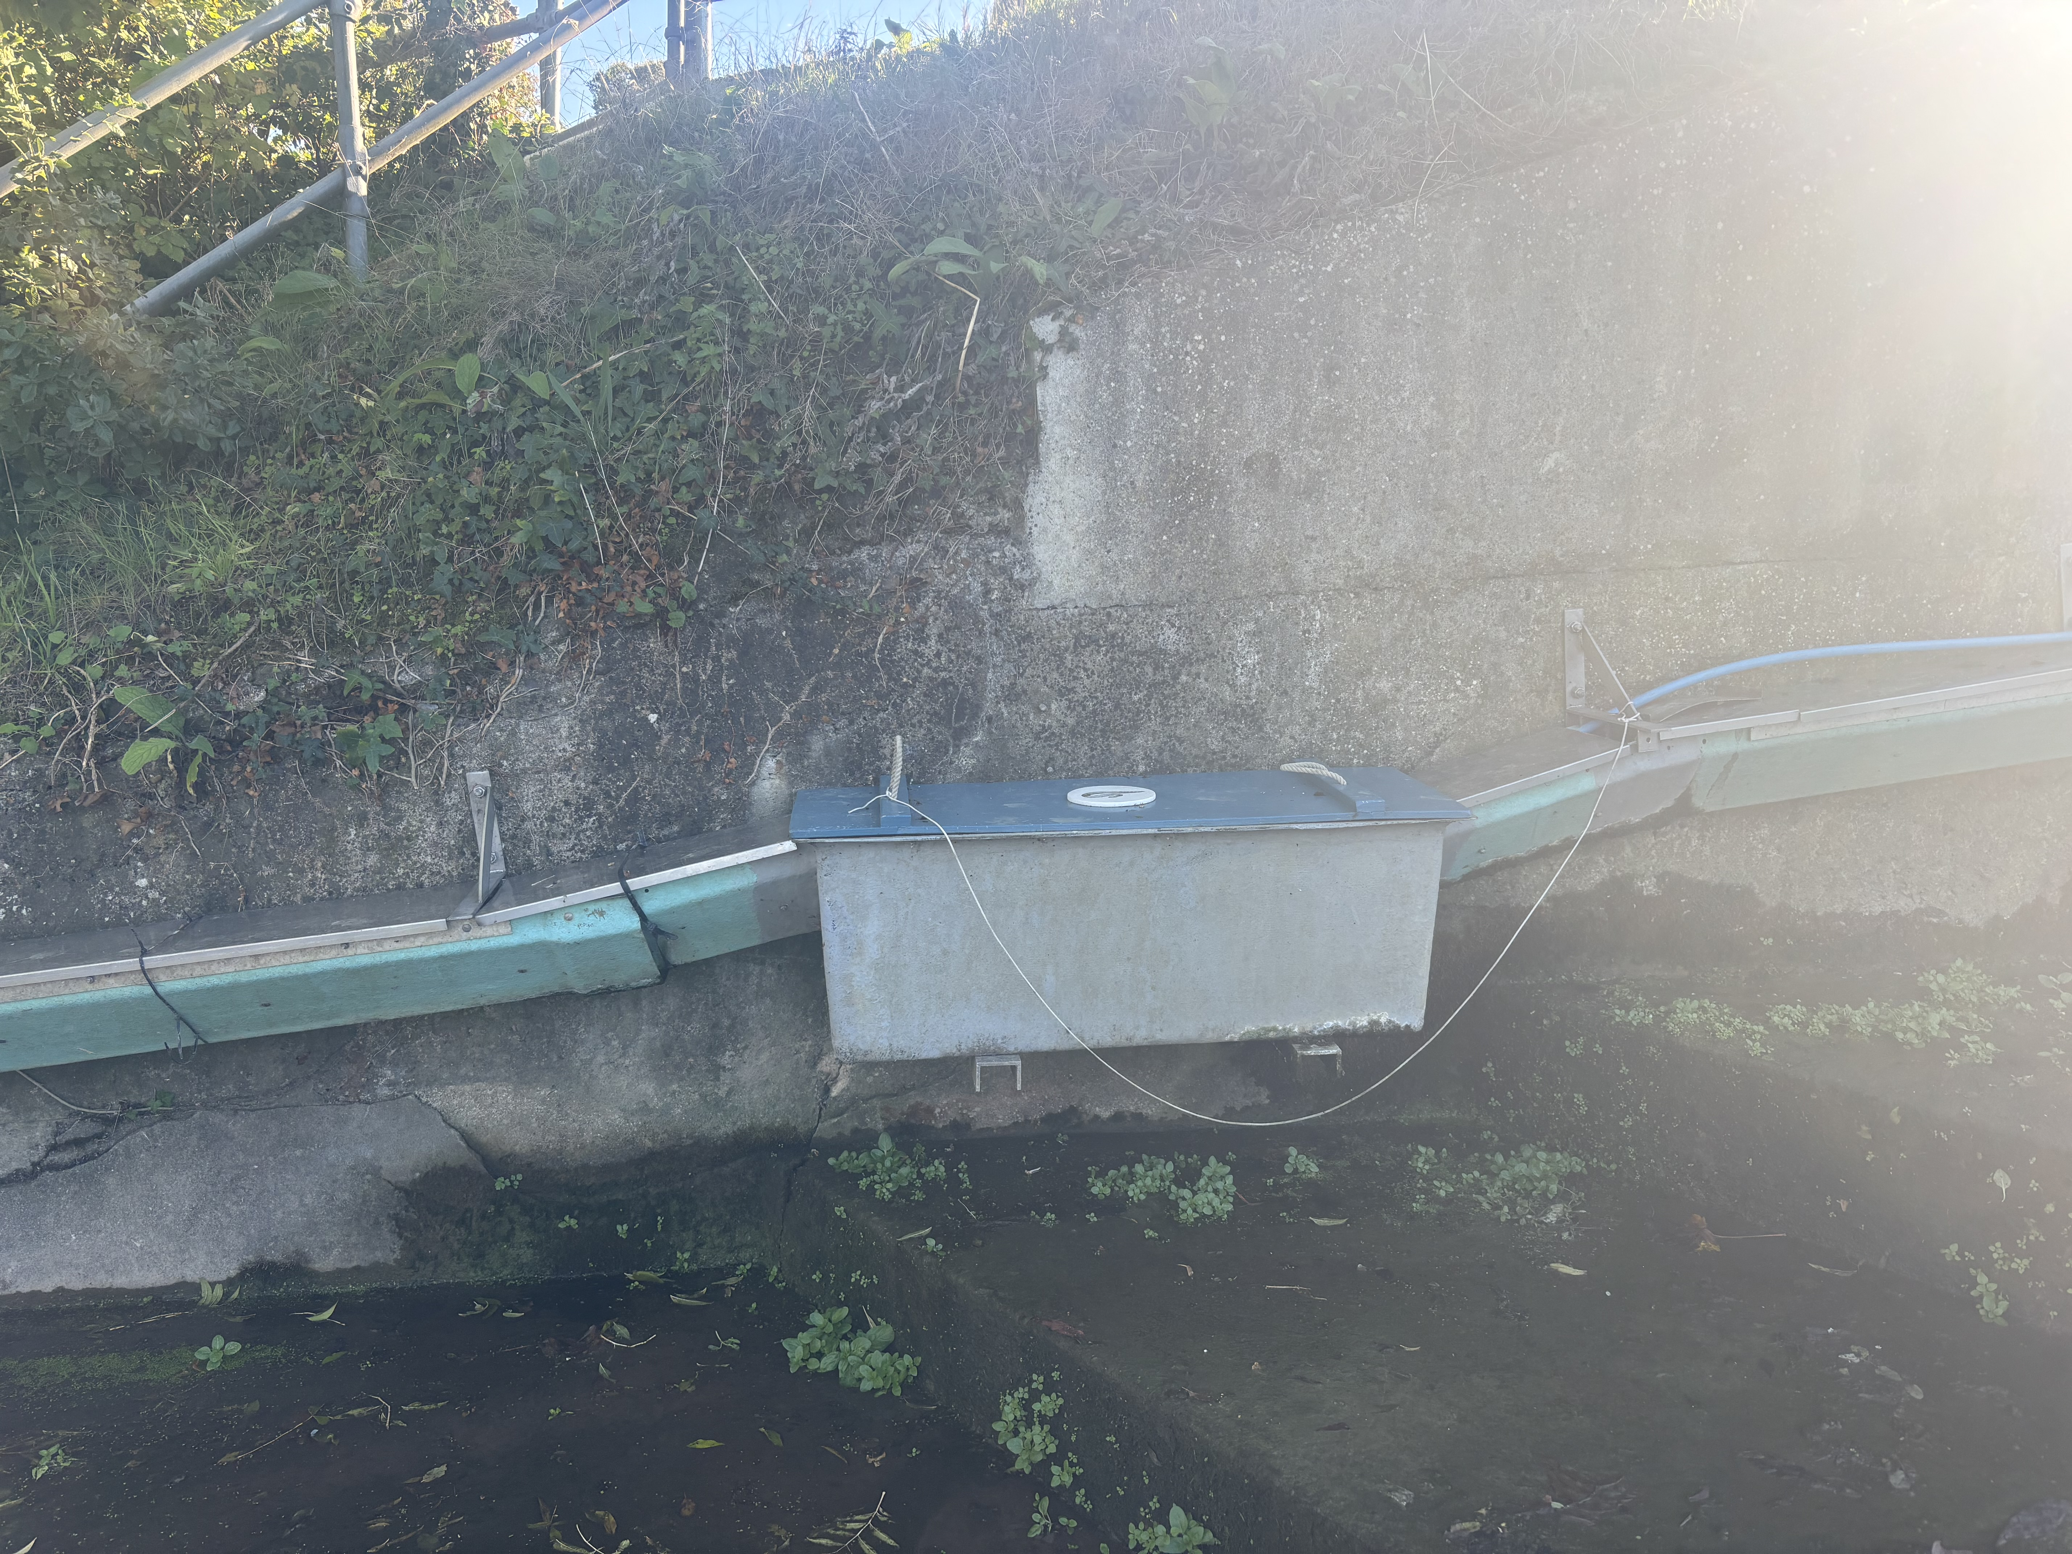
a) b)
Holding tank with mesh overflow
Pipe
Guttering with climbing substrate
Flow
a
Figure 2.3: a) Schematic and b) photograph of the trap design at the Thames - Molesey Weir. Schematic taken from Naismith and Knights (1988), image credit: ZSL\Ella Carbery-Tarrant.

2.3 Citizen Science Training
Citizen scientists are fundamental to the delivery of the Thames European Eel Project, contributing to long-term data collection and site monitoring. Trap checks at Medway - Allington Lock and Thames - Molesey Weir were carried out by trained volunteer citizen scientists. Training was delivered by ZSL and local partner organisations at each site (Table 2.1), through a two-hour induction covering:

- European eel biology, ecology and threats
- Survey objectives and methodology
- Handling, measuring and releasing eels and bycatch
- Use of the online data submission portal
- Health and safety procedures

All participants were briefed on any potential risks associated with sampling as well as the Emergency Response Plan for their specific site before reading and signing a risk assessment.

In 2025, 73 volunteers attended training sessions, bringing the cumulative total of trained citizen scientists to over 1,300 since the citizen science aspect of the TEEP launched in 2011. At Roding - Redbridge Roundabout, monitoring was conducted by trained ZSL staff with up to two internal volunteers, as this site requires entering the river. During 2025, traps at Roding - Redbridge Roundabout traps were checked on rotation by ZSL, Environment Agency and SEA LIFE London Aquarium staff.

Table 2.1: Number of volunteers trained in 2025 at Medway - Allington Lock, Roding - Redbridge Roundabout and Thames - Molesey Weir and the corresponding partner organisations that collaborated with ZSL.
trap location | Number of Volunteers Trained | Partner Organisation/ collaborators
Medway - Allington Lock | 10 | Medway Valley Countryside Partnership
Roding - Redbridge Roundabout | 23 | SEA LIFE London Aquarium and Environment Agency
Thames - Molesey Weir | 40 | The South East Rivers Trust

2.4 Monitoring Method
On each survey day, traps were thoroughly checked for eels. Captured eels were counted and measured to the nearest millimetre. Measurements were taken by placing eels into a clear sandwich bag using a net and gently aligning them against a ruler fixed to a solid board (Figure 2.4).

Measuring individuals allows distinction between elvers (<120mm) and older eels (>120mm). This differentiation is essential because eels exceeding 120mm are unlikely to have entered the river during the current monitoring season, representing resident individuals from previous years, while eels of <120mm are new recruits migrating upstream within the year of monitoring. Recruitment is therefore assessed based on the abundance of elvers recorded.

When more than 50 individuals were caught, a random sub-sample of 50 individuals were measured, while the remaining were only counted. All eels were subsequently released upstream of the trap and river barrier to reduce the likelihood of recapture. Monitoring was conducted and permitted under licence from the Environment Agency, in accordance with the Salmon and Freshwater Fisheries Act, 1975 (HM Government, 1975).

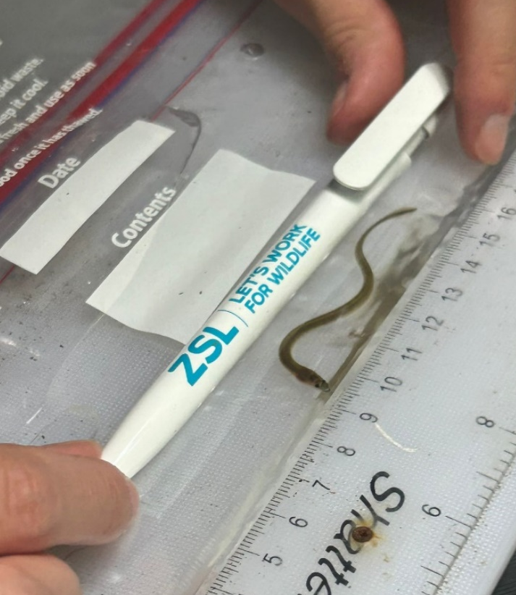
Figure 2.4: ZSL staff measuring an elver at the Roding - Redbridge Roundabout site. Image credit: ZSL\Zora Quadir.

2.5 Data Processing
After each trap check, surveyors uploaded data including eel counts, length measurements and survey dates to a secure online database hosted by ZSL. All entries underwent quality assurance checks by ZSL staff, who contacted volunteers when clarification was needed. Data were then compiled, analysed and produced into figures using Microsoft Excel. Only elvers (<120mm) were included in analysis.

Due to trap designs, efficiency and trapping durations varying among sites, elver catch numbers could not be directly compared. Instead, annual recruitment was standardised using Catch Per Unit Effort (CPUE):

Catch Per Unit Effort = Total Number of Elvers Caught ÷ Total Number of Successful Trapping Days

This metric allows recruitment to be compared across years, while accounting for variability in trapping effort, such as occasional trap failures or high flows, for example.

Catch totals and CPUE values are reported annually to the Thames Eel Action Plan Working Group and, via the Environment Agency, to the WGEEL.

3. Results

3.1 Eel Catches
A total of 485 European eels were caught across traps in 2025, of which 474 were elvers (<120mm long). These data, split by trap location, are summarised in Table 3.1. Overall counts collected in 2025 are highlighted in Table 3.2.

Table 3.1: Summary of European eels (Anguilla anguilla) caught during the 2025 monitoring season at each trap, split into Total Elver Count (eels <120mm), Total Eel Count (>120mm), Overall Total (Elvers and Eels Combined), Minimum Length (mm), Maximum Length (mm) and Mean Length (mm). Total Elver Count is highlighted to signify data used to assess eel recruitment.
Trap Location | Total Elver Count (<120mm) | Total Eel Count (>120mm) | Overall Total (Elvers and Eels Combined) | Minimum Length (mm) | Maximum length (mm) | Mean length (mm)
Medway - Allington Lock | 330 | 7 | 337 | 61 | 255 | 81.7
Roding - Redbridge Roundabout (Left trap) | 51 | 1 | 52 | 61 | 123 | 84.2
Roding - Redbridge Roundabout (Right trap) | 6 | 0 | 6 | 70 | 90 | 79.5
Roding - Redbridge Roundabout (Combined) | 57 | 1 | 58 | 61 | 123 | 83.7
Thames - Molesey Weir | 30 | 2 | 32 | 70 | 170 | 92.3

Table 3.2: Summary of European eels (Anguilla anguilla) caught during the 2025 monitoring season split into Total Elver Count (<120mm), Total Eel Count (>120mm), Overall Total (Elvers and Eels Combined). Total Elver Count is highlighted to signify data used to assess eel recruitment.
Total Elver Count (<120mm) | Total Eel Count (>120mm) | Overall Total (Elvers and Eels Combined)
474 | 11 | 485

3.2 Catch Per Unit Effort (CPUE)
Annual elver CPUEs were calculated for the traps monitored in 2025 (Table 3.3). Data from the left and right Roding - Redbridge Roundabout traps were combined to calculate one CPUE value for the site. Among the three index sites, Medway - Allington Lock recorded the highest CPUE at 3.84, followed by Roding - Redbridge Roundabout at 0.25, and Thames - Molesey Weir at 0.22. The Roding - Redbridge Roundabout site showed the largest decrease in CPUE from 2024 to 2025, while Thames - Molesey Weir displayed only a minor decline. In contrast, Medway - Allington Lock exhibited a notable increase, rising from 0.60 in 2024 to 3.84 in 2025.

Figures 3.1, 3.2 and 3.3 illustrate annual CPUE trends for Medway - Allington Lock, Roding - Redbridge Roundabout, and Thames - Molesey Weir, alongside the ICES estimated elver recruitment (%) for the North Sea and Elsewhere in Europe indices (ICES, 2025). These indices represent recruitment as a percentage of the 1960 to 1979 geometric mean, providing a broader European context for the Thames catchment data.

Table 3.3: Annual Catch Per Unit Effort (CPUE) of European eel (Anguilla anguilla) for the three trap sites monitored from 2012 to 2025. NA values for other sites in 2020 and 2021 were due to COVID-19 restrictions preventing data collection at these locations.
TRAP LOCATION | ANNUAL CPUE
TRAP LOCATION | 2012 | 2013 | 2014 | 2015 | 2016 | 2017 | 2018 | 2019 | 2020 | 2021 | 2022 | 2023 | 2024 | 2025
Medway - Allington Lock | 10.90 | 133.30 | 66.68 | 2.34 | 0.48 | 1.49 | 0.76 | 0.87 | NA | 3.29 | 1.40 | 2.21 | 0.60 | 3.84
Roding - Redbridge Roundabout | 0.08 | 0.47 | 7.20 | 2.36 | 0.83 | 1.15 | 3.61 | 1.79 | NA | NA | 0.73 | 0.32 | 2.00 | 0.25
Thames - Molesey Weir | 0.82 | 14.63 | 2.10 | 1.68 | 1.63 | 0.82 | 0.67 | 0.57 | 0.61 | 0.90 | 0.09 | 0.04 | 0.23 | 0.22

Figure 3.1: European eel (Anguilla anguilla) Catch Per Unit Effort (CPUE) and stock recruitment indices (%) for the North Sea (orange line) and Elsewhere in Europe (blue line) from 2012 to 2025 at Medway - Allington Lock. Index values represent eel recruitment as a percentage relative to the geometric mean of 1960 to 1979 values. 2025 index values are provisional. ICES recruitment indices data were obtained from ICES (2025). Data missing in 2020 and 2021 was due to COVID-19 disruptions.

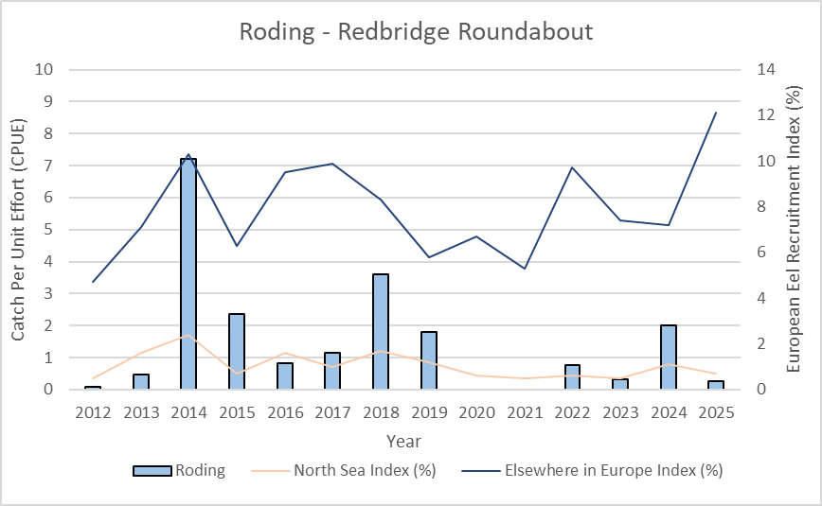

Figure 3.2: European eel (Anguilla anguilla) Catch Per Unit Effort (CPUE) and stock recruitment indices (%) for the North Sea (orange line) and Elsewhere in Europe (blue line) from 2012 to 2025 at Roding - Redbridge Roundabout. Index values represent eel recruitment as a percentage relative to the geometric mean of 1960 to 1979 values. 2025 index values are provisional. ICES recruitment indices data were obtained from ICES (2025). Data missing in 2020 and 2021 was due to COVID-19 disruptions.

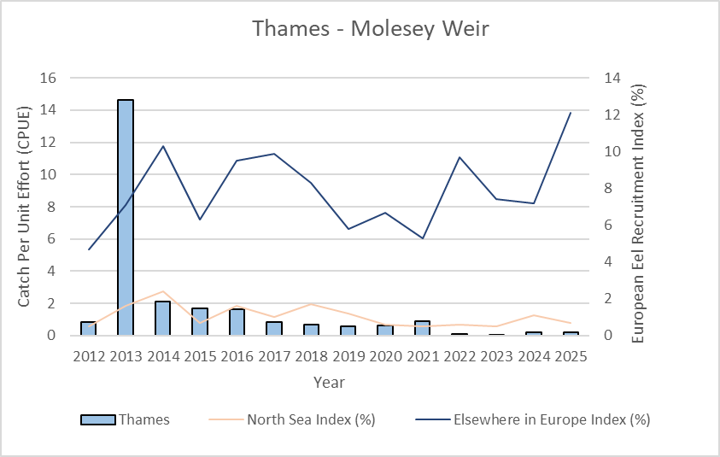
Figure 3.3: European eel (Anguilla anguilla) Catch Per Unit Effort (CPUE) and stock recruitment indices (%) for the North Sea (orange line) and Elsewhere in Europe (blue line) from 2012 to 2025 at Thames - Molesey Weir. Index values represent eel recruitment as a percentage relative to the geometric mean of 1960 to 1979 values. 2025 index values are provisional. ICES recruitment indices data were obtained from ICES (2025).

4. Discussion

4.1 Catch Data
A consistent methodology for monitoring eel recruitment across the Thames RBD has now been in place for 20 years at Roding - Redbridge Roundabout, 12 years at Medway - Allington Lock and 14 years at Thames - Molesey Weir. These long-term datasets provide a valuable record of changes in European eel recruitment over time, offering insight into spatial and temporal variation across the catchment.

Monitoring at multiple sites enables a broader understanding of recruitment trends throughout the Thames RBD to be identified. While annual fluctuations in CPUE are expected, overall recruitment levels remain substantially lower than those recorded in the 1980s.

Data collected from the three index sites are submitted annually to ICES, where they contribute to international stock assessments, management advice and the development of eel recovery strategies.

4.1.1 Medway - Allington Lock

At the Medway - Allington Lock site, CPUE increased from 0.60 in 2024 to 3.84 in 2025 and showed the highest CPUE out of all three index sites. Except for 2016 when CPUE reached 0.48, the 2024 CPUE value represented the lowest in the 12-year dataset. Annual fluctuations in CPUE are typical, but the trend at this site in 2025 aligns with the ICES Elsewhere in Europe index which rose from 7.2% in 2024 to 12.1% in 2025 of the 1960 to 1979 geometric mean. Conversely, the North Sea index declined from 1.1% to 0.7% over the same period (ICES, 2025).

4.1.2 Roding - Redbridge Roundabout

The Roding - Redbridge Roundabout site underwent modifications by the Environment Agency in July 2024, halfway through the monitoring season. At the start of the monitoring season, the eel pass pump was non-functional, but this was later repaired by the Environment Agency who fixed the pump and replaced two of the eel tiles at the downstream end of the weir. During the same period, the Environment Agency also installed a new baffle fish pass on the weir to enhance fish passage (Figure 4.1). This year, the eel pass operated continuously throughout the 2025 monitoring season (Figure 4.2). It remains unclear whether these construction works and/or subsequent modifications had any direct impact on CPUE at the site.

At Roding - Redbridge Roundabout, CPUE fell from 2.00 in 2024 to 0.25 in 2025, making this the lowest value observed in the dataset since 2012 (CPUE value of 0.08). The decline at this site parallels the drop in the ICES North Sea index (from 1.1% in 2024 to 0.7% in 2025), indicating that broader regional trends may have also influenced recruitment. However, this trend differs from the Elsewhere in Europe index (ICES 2025).

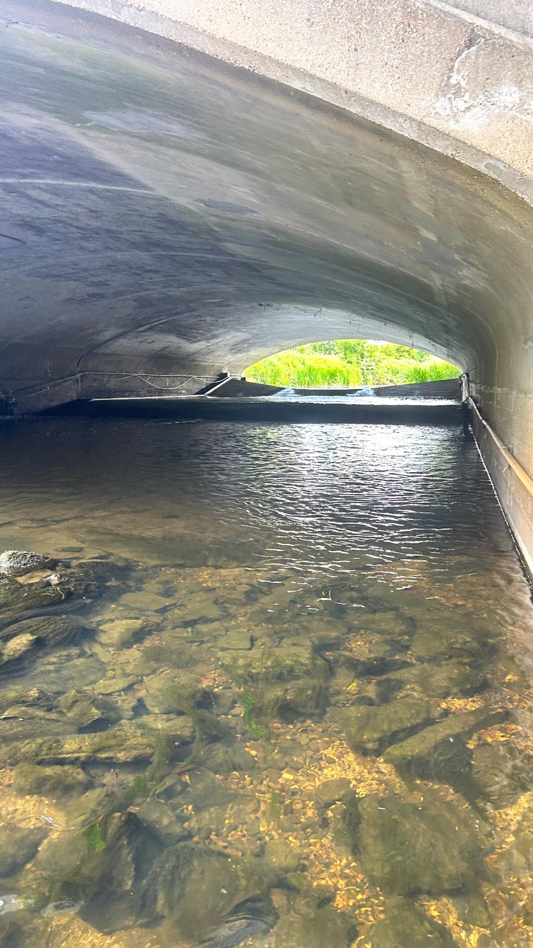 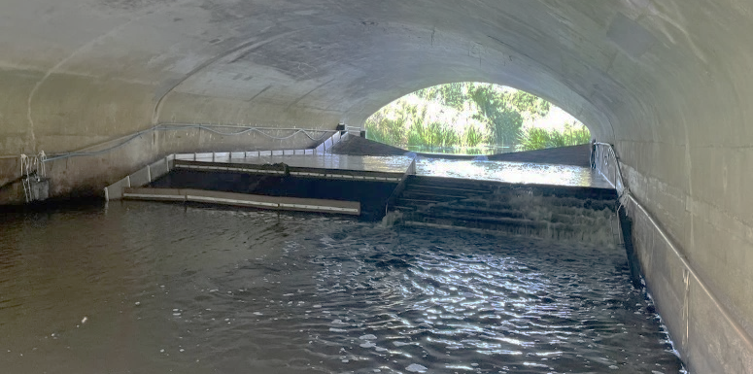Figure 4.1: View of the Roding - Redbridge Roundabout site a) before and b) after the Environment Agency installed a baffle fish pass on the weir in July 2024, midway through the elver monitoring season. Image credits: ZSL\Ella Wallis.
- b)

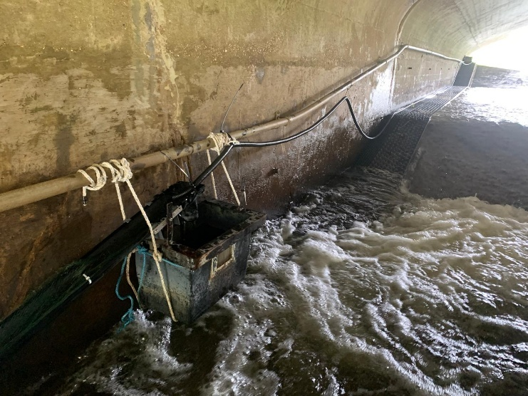
Figure 4.2: View of the eel pass at Roding - Redbridge Roundabout site. Image credits: ZSL\Azra Glover.

4.1.3 Thames - Molesey Weir

At Thames - Molesey Weir, CPUE remained stable, with only a marginal decrease from 0.23 in 2024 to 0.22 in 2025 and showed the lowest CPUE out of all three index sites. This continues a pattern of consistently low recruitment levels recorded since 2022, following high recruitment between 2013 and 2016. The 2025 results correspond with the North Sea index, which also remains low and relatively stable across the past six years (ranging between 0.5 to 1.1% since 2020) (ICES, 2025). Despite this, recruitment at this site remains among the lowest across the Thames River Basin District.

5. References
Clifton-Dey, D., July 2024. Personal communication. Wey – Weybridge trap site, Surrey, UK.
Council Regulation (EC) No. 1100/2007 of 18 September 2007 establishing measures for the recovery of the stock of European eel OJ L 248, 22.9.2007, pp.17–23. Available: http://data.europa.eu/eli/reg/2007/1100/oj
Cox, T. (2019). A fyke-netting study of yellow eels in the River Thames. Zoological Society of London.
Cresci, A. (2020). A comprehensive hypothesis on the migration of European glass eels (Anguilla anguilla). Biological Reviews, 95(5), pp.1273-1296.
DEFRA (2010). Eel Management Plans for the United Kingdom: Thames River Basin District. Available: https://www.eelregulations.co.uk/pdf/demp.pdf
Feunteun, E. (2002). Management and restoration of European eel population (Anguilla anguilla): an impossible bargain. Ecological Engineering, 18(5), pp.575-591.
Griffioen, A.B. et al. (2024) ‘Glass eel migration in an urbanized catchment: An integral bottleneck assessment using mark-recapture’, Movement Ecology, 12(1). doi:10.1186/s40462-023-00446-6.
Gollock, M., Curnick, D. and Debney, A. (2011). Recent recruitment trends of juvenile eels in tributaries of the River Thames. Hydrobiologia, 672(1), pp.33-37.
Harrison, A., Walker, A., Pinder, A., Briand, C. and Aprahamian, M. (2014). A review of glass eel migratory behaviour, sampling techniques and abundance estimates in estuaries: implications for assessing recruitment, local production and exploitation. Reviews in Fish Biology and Fisheries, 24(4), pp.967-983.
HM Government (1975). The Salmon and Freshwater Fisheries Act 1975. HMSO, London.
ICES (2024). European eel (Anguilla anguilla) throughout its natural range. In Report of the ICES Advisory Committee, 2024. ICES Advice 2024, ele.2737.nea, https://doi.org/10.17895/ices.advice.27100516
Jacoby, D., Casselman, J., Crook, V., DeLucia, M., Ahn, H., Kaifu, K. et al. (2015). Synergistic patterns of threat and the challenges facing global anguillid eel conservation. Global Ecology and Conservation, 4, pp.321-333.
Lieschke, J., Dean, J. and Pickworth, A. (2019). Extending the effectiveness of electrofishing to estuarine habitats: Laboratory and field assessments. Transactions of the American Fisheries Society, 148(3), pp.584-591.
Naismith, I. and Knights, B. (1988). Migrations of elver and juvenile European eels, Anguilla anguilla L., in the River Thames. Journal of Fish Biology, 33, pp.166-175.
Pike, C., Crook, V. and Gollock, M. (2020). Anguilla anguilla. The IUCN Red List of Threatened Species 2020: e.T60344A152845178. https://dx.doi.org/10.2305/IUCN.UK.2020-2.RLTS.T60344A152845178.en. Accessed on 24 September 2024.
Piper, A., Wright, R. and Kemp, P. (2012). The influence of attraction flow on upstream passage of European eel (Anguilla anguilla) at intertidal barriers. Ecological Engineering, 44, pp.329-336.
Pons-Hernandez, M. (2024) ‘“missing the trees for the forest?” an analysis of the harms to European eels caused by their trafficking and Trade’, Critical Criminology, 32(1), pp. 77–95. doi:10.1007/s10612-024-09765-5.
Righton, D., Verhelst, P. and Westerberg, H. (2025) ‘The blueprint of the European Eel Life Cycle: Does life‐history strategy undermine or provide hope for population recovery?’, Fish and Fisheries, 26(4), pp. 505–519. doi:10.1111/faf.12894.
Shoothill GaugeMap (2024). GaugeMap – Latest River, Flow and Groundwater Levels Map for Britain & Ireland. Redbridge (Roding). Available: https://www.gaugemap.co.uk/#!Detail/1402/1554. Accessed on 6 November 2024.
Sonne, C. et al. (2021) ‘European eel population at risk of collapse’, Science, 372(6548), pp. 1271–1271. doi:10.1126/science.abj3359.
Wright, R., Piper, A., Aarestrup, K., Azevedo, J., Cowan, G., Don, A. et al. (2022). First direct evidence of adult European eels migrating to their breeding place in the Sargasso Sea. Scientific Reports, 12(1), p.15362.

